 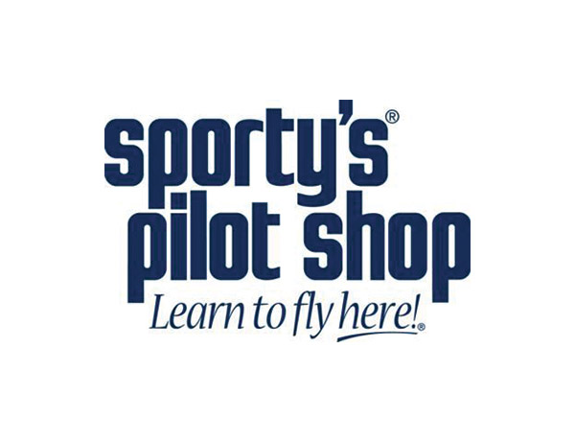

**Ladies Jewelry – Tortoise shell color necklace with pendant**



Item #33D

Retail value $50

**2022 LOBO/Lancair landing Auction Item!**