

***Enjoy the hot tub, billiards room, game room, seven fireplaces, wine room, dedicated theater room, two large decks, four steam showers, six bedrooms, heated drives and decks… and much much more!!***

**Available dates:**

**10/12-11/1/22 11/28-12/14/22**

**4/3-4/6/23 4/10-4/13/23**

**4/17-4/20/23 May 2023 6/1-6/11/23**

**July, August, Sept - weekdays Mon thru Wed (3 days)**

**\*Reservation requests are based on availability at time of booking**

**$5,000 - $10,000.00 value depending on booking dates.**

**Requires a signed contract, 1500.00 refundable damage deposit, and credit card on file. Guests are responsible for the $600.00 cleaning fee.**

**Please note we love a good party, but parties, weddings, and receptions are not allowed.**

**\*\*\* See website below for more info.**

***If interested YOU REALLY NEED TO LOOK AT THE WEBSITE !!!!!!***

www.skicoppercolorado.com

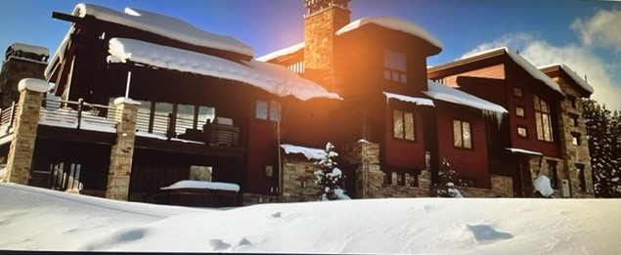

***Enjoy a 3-night stay at the luxurious Lodge At Timberline in Copper Mountain, Colorado.***

**Ideal for 4 -6 families… Great for family reunions, etc.**

***Timberline Lodge: True Ski in/Out, Featured on the cover of Denver Life magazine***

Item # 19 Retail value $5k to $10k

**2022 LOBO/Lancair landing Auction Item!**