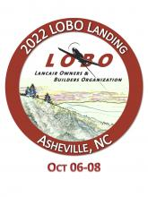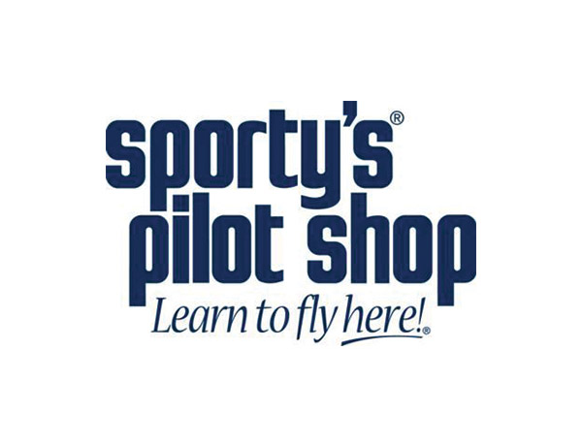



**Aircraft Paint Scheme &Decal Design Specialists**



**A Global Leader in Aviation  
Safety & Performance**



One Base Design

Item #23

Retail value $1200

**2022 LOBO/Lancair landing Auction Item!**