

**OXYpack3 – 2 Person Flow Meter Oxygen System With 22 CU. Ft. Cylinder**



**PRECISE FLIGHT**



**A Global Leader in Aviation  
Safety & Performance**



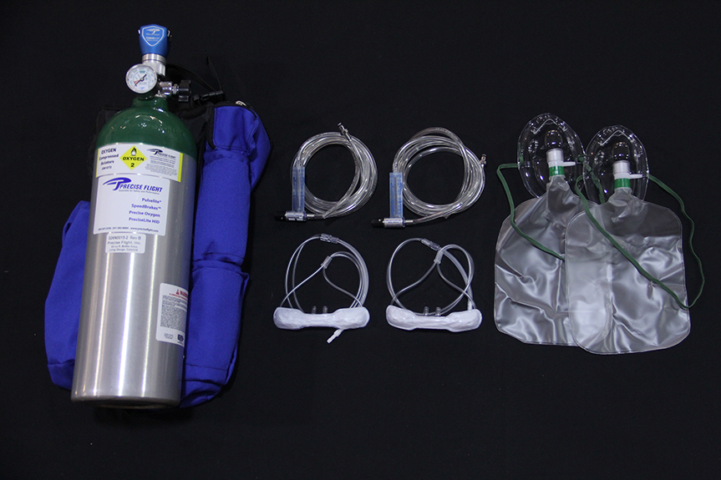

Item #22

Retail value $1265

**2022 LOBO/Lancair landing Auction Item!**