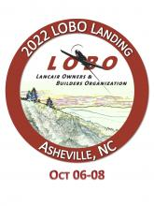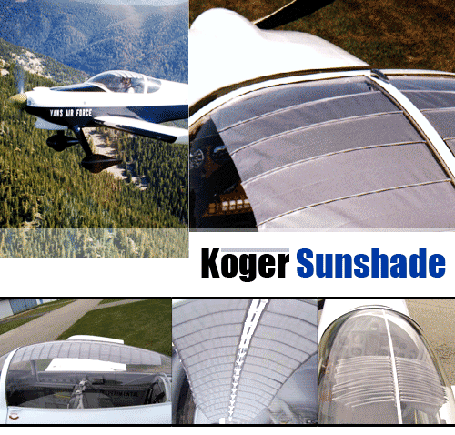

**Koger Sunshade for 2 seat Lancair**

Item # 16

*The Koger Sunshade was developed to provide protection from the sun while flying an airplane that has a large bubble plastic canopy*

Retail value $240

**2022 LOBO/Lancair landing Auction Item!**