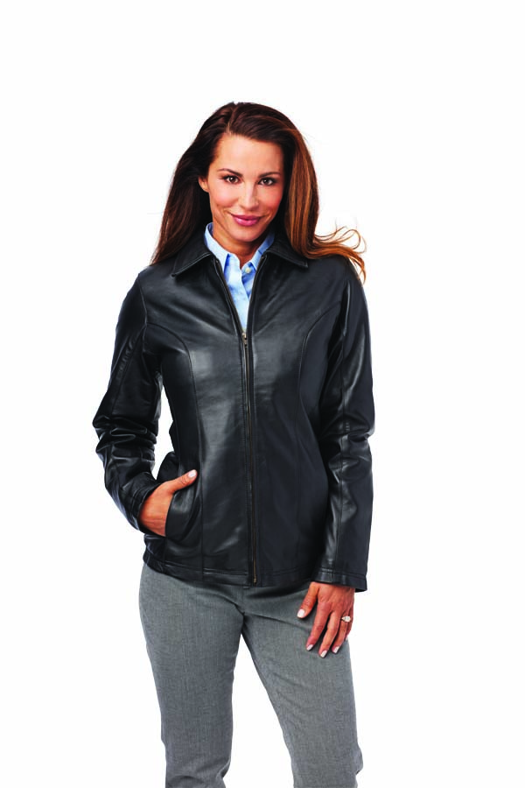 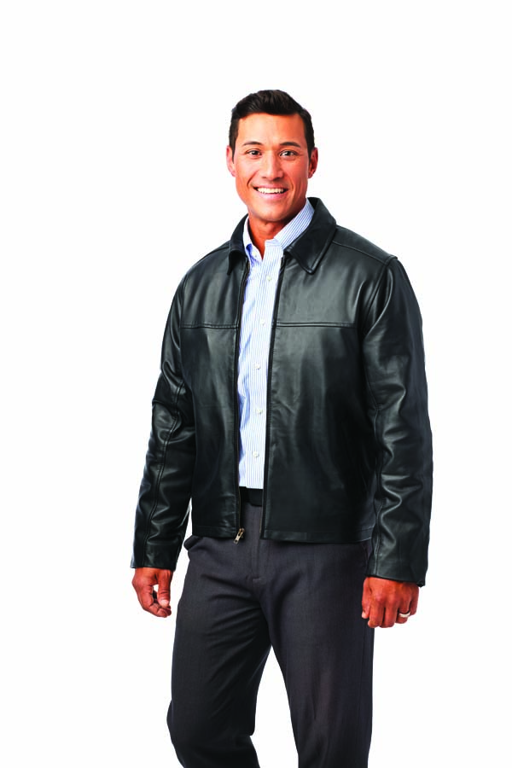

**Certificate for jacket in your size**. Men’s or Women’s

**Pratt and Whitney Custom Ordered Leather Jacket**

Item #21

Retail value $300

**2022 LOBO/Lancair landing Auction Item!**