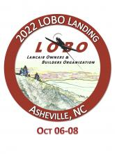

**TS FLIGHTLINES**

**Aviation Hose Assemblies**

***Gift Certificate for $100 off any hose order***

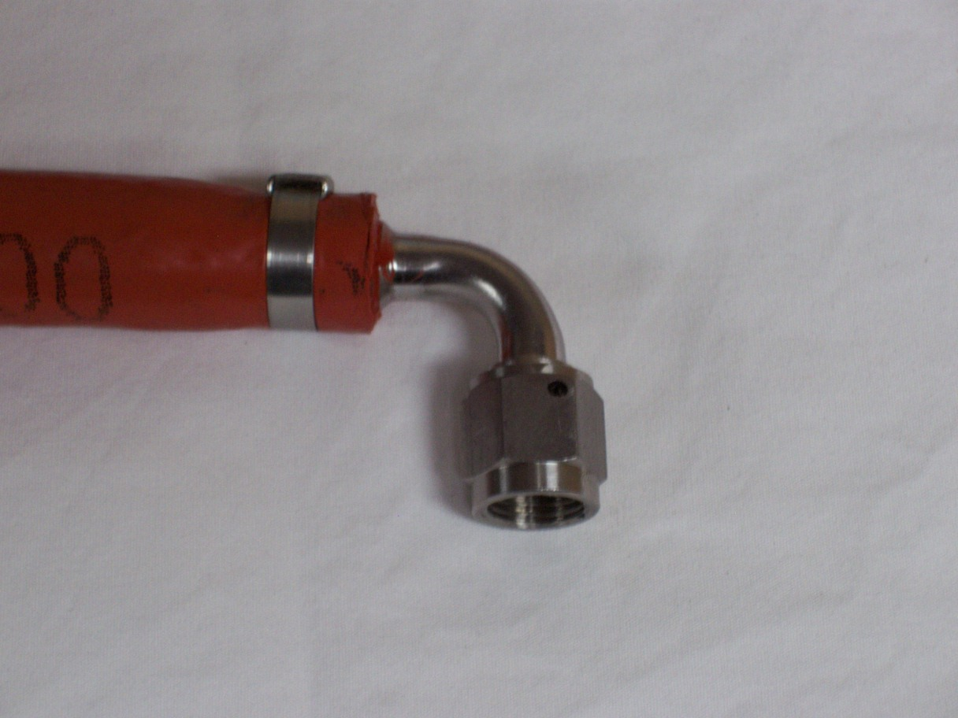

Item # 27

Retail value $100

**2022 LOBO/Lancair landing Auction Item!**