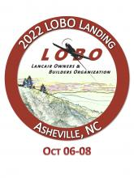 

**Ladies Jewelry: 4 Silver Necklaces**



Item #33A

Retail value $100

**2022 LOBO/Lancair landing Auction Item!**