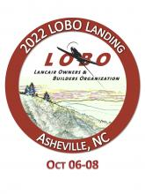

Grey Handbag

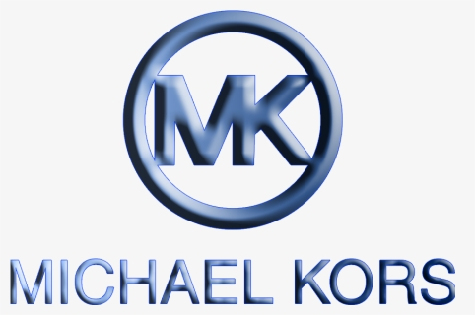

Item #31

Retail value $250

**2022 LOBO/Lancair landing Auction Item!**