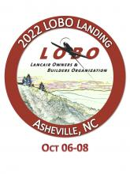

Men’s Polo Shirt & Travel Mug

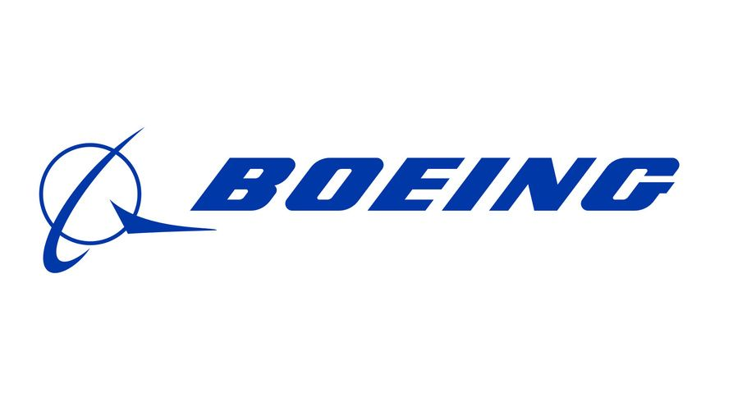

Item #5

Retail value $175

**2022 LOBO/Lancair landing Auction Item!**