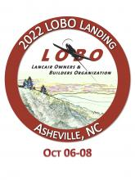

**Lancair International**

**Nose Gear Links for Newly Released SB**

***Update your nose gear retract links to the new design that***

***does not impose side loads on the joint and attachment bolt***

**This link, with previous attachment methods, has been one of the highest sources of nose gear retractions during ground operations on the retractable Legacy & IV Series**

***This does NOT apply to the 300 Series Lancairs***

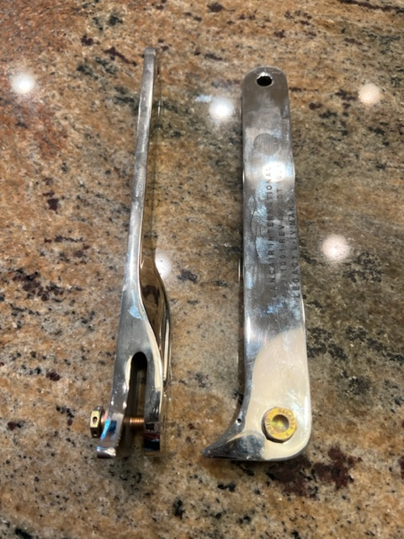

Item # 17

Retail value $950

**2022 LOBO/Lancair landing Auction Item!**