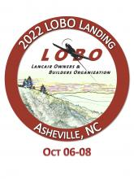 

**Lightspeed Survival Gear Kit**

The Lightspeed Survival Gear Kit is a canvas military-styled bag filled with the basic tools needed for shelter, fire, water, first aid and rescue, a multi-purpose shovel and a Survival Checklist Deck.

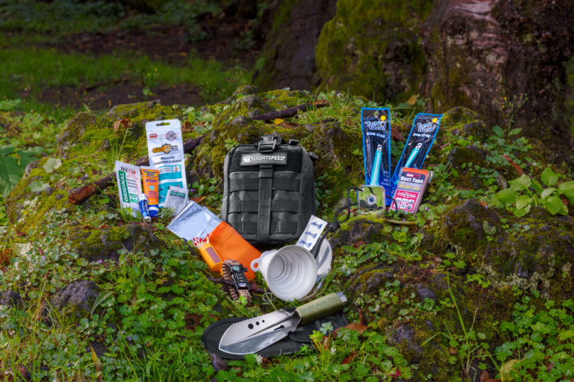

Item #18

Retail value $129

**2022 LOBO/Lancair landing Auction Item!**