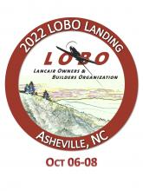

**J. Barrett**

**Carbinge with Keepers**

***Set of two Carbon Fiber Hinges***

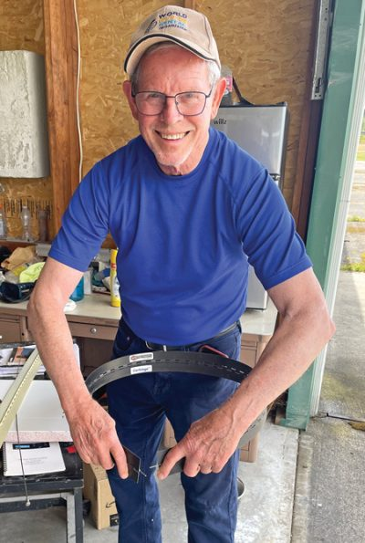

Item # 15

Retail value $500

**2022 LOBO/Lancair landing Auction Item!**