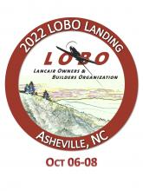 

This Auction prize includes 2 autographed books by Sarah Byrn Rickman from the Museum collection, and a bottle of wine with a glass from the last WASP Homecoming.



**The Women Airforce Service Pilots (WASP):**

The WASP was established during World War II, on August 5, 1943. The WASP flew a total of 60 million miles performing a variety of missions. These women flew military aircraft, were considered civilians, not granted military benefits. The WASP were a brave and dedicated group of aviators who helped the U.S. win the WWII battles in the air. They did not participate in combat directly-- they ably took the place of male pilots who fought in the air war.   
  
The groundbreaking steps taken by the WASP paved the way for today's generation of military female aircrew currently engaged in conflicts around the world. The National *WASP* WWII *Museum* in Sweetwater, Texas, is working to preserve the WASP history from World War II.



This Auction prize includes 2 autographed books by Sarah Byrn Rickman from the Museum collection, and a bottle of wine with a glass from the last WASP Homecoming

Item #35

Retail value $50

**2022 LOBO/Lancair landing Auction Item!**