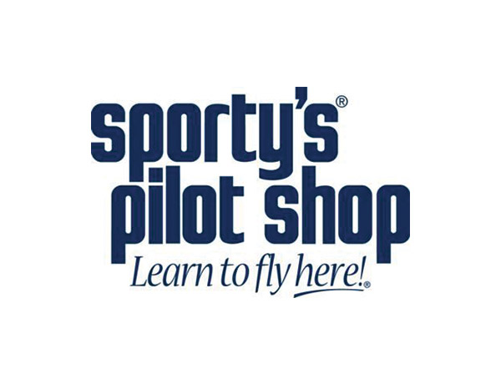

**David Clark H10-13.4 Headset**

David Clark's most popular model, offering good noise reduction in a nearly indestructible design

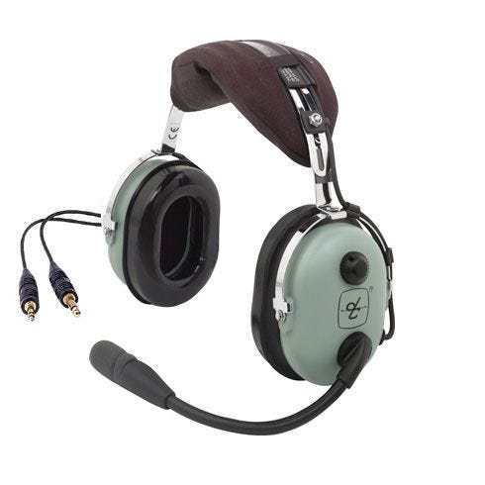

Item #9

Retail value $380

**2022 LOBO/Lancair landing Auction Item!**