Lancair 320 – C-GLPV Specifications Sheet
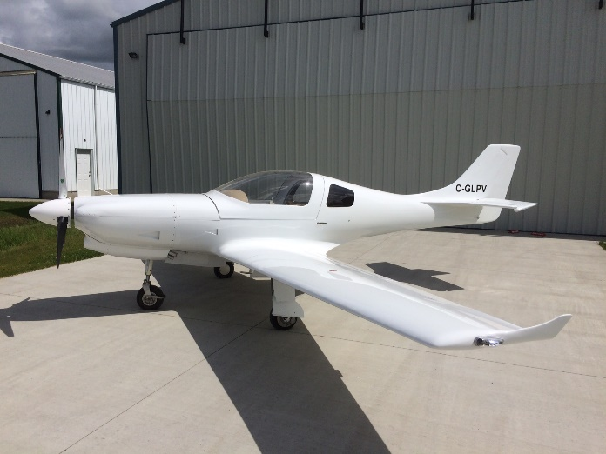
- 50 hours total time on engine and airframe
- First flight – October 2017
- 200 kts cruise
- Lean-of-peak operations ready
Engine and Propellor
- Lycoming O-320 D1F engine
- Fuel injection
- Traditional and electronic magnetos
- Electro Air Magneto and Starter Switch
- 8 amp backup alternator
- Three bladed MT wood/composite propeller (Fall 2018)
- Two oil analysis (25 and 50 hours) show normal metal values
- Engine analysis (Savvy Analysis) shows normal engine parameters
- GAMI test performed and GAMI advises that GAMI injectors are not required to perform lean-of-peak operation (huge fuel saving, cooler engine temperatures = longer engine life, small loss of TAS)
- 1800 TBO engine should easily go to 3000 hours on-condition
Airframe
- Wing extensions added to take the aircraft out of the high-performance category.
- Whelan LED position and strobe lights
- LED landing lights
- Professionally painted at Avialta Helicopter Maintenance (CZVL)
- Vertical Power Electronic Circuit Breaker System
Avionics
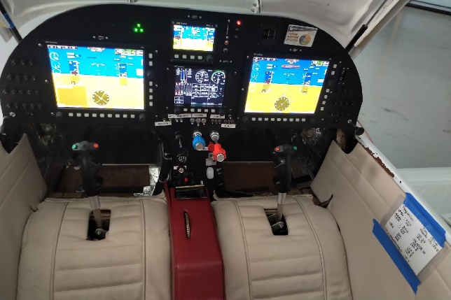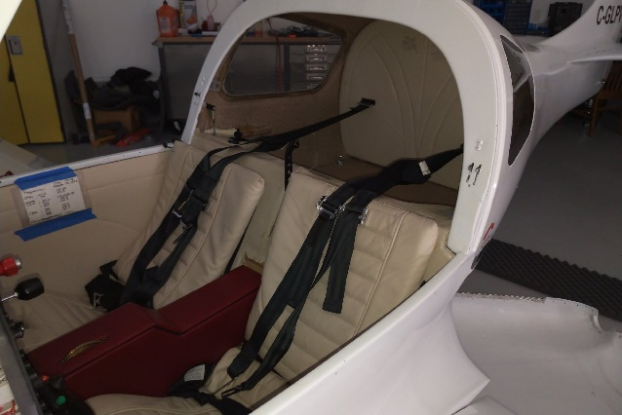
- Displays
  - Dual Grand Rapids GRT Hrx 10.4” displays
  - Dual Attitude Heading Reference System (AHRS)
  - Adaptive AHRS
  - Synthetic Vision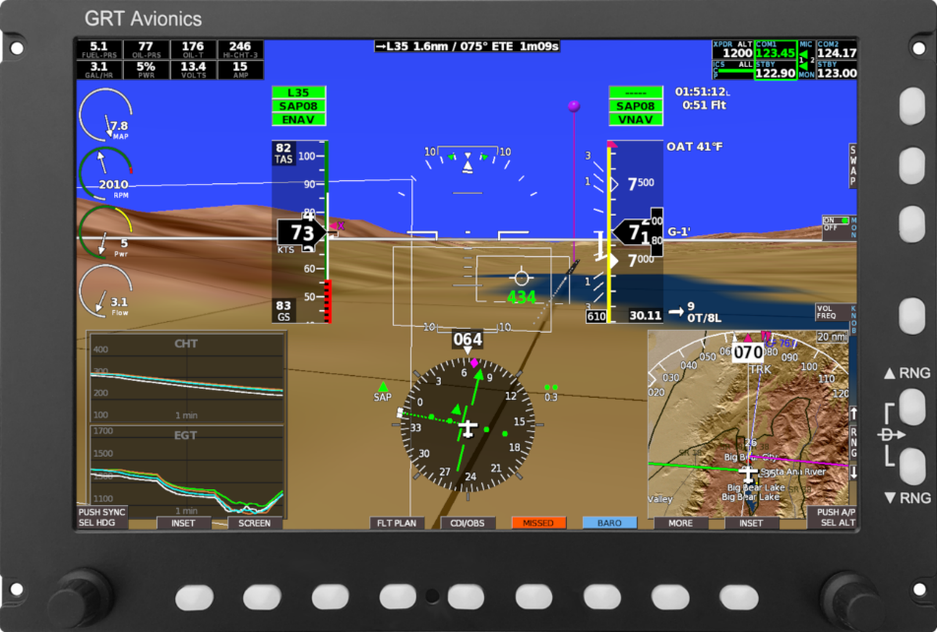

  - GRT Mini Backup (attitude, altitude, heading, speed, navigation) with Synthetic Vision
  - GRT Mini Back-up Battery System 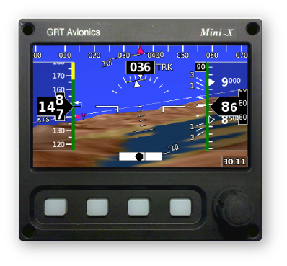
- Engine Display and Monitoring
    - Grand Rapids EIS 4000 Engine Monitoring System
    - VPower Electronic Circuit Breaker Control
    - GRT Sport SX Engine Display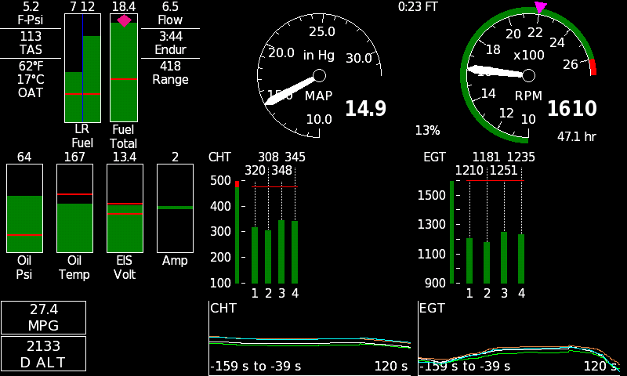
- Communication
    - Dual VHF Comm Radios
    - Single VHF NAV Radio
    - PS Engineering Audio Controller
    - All radios and intercom controlled via EFIS displays.
    - LIMO connector jacks for headsets
- Navigation
    - GPS/WAAS LPV Receiver
    - Dual GPS Navigation (with dual AHRS)
    - Single GPS Navigation (with Mini Back-up)
    - All radio tuning via EFIS displays.
- Surveillance
    - Trig TT22 Transponder
    - Mode S and ADS-B Out
    - Transponder controlled by EFIS displays.
- Autopilot
    - Grand Rapids Autopilot
    - Pitch and roll
    - Controlled by either EFIS
- Miscellaneous
    - Symmetrical cockpit so the aircraft can be flown from either seat (HRx displays can display attitude or navigation)
    - 406 ELT
    - Capacitance fuel probes
    - Infinity Stick Grips with trim switch plus 5 buttons
    - AOA Sport Angle of Attack System
    - Two USB chargers
Damage History
The aircraft had a nosewheel failure from a pilot induced oscillation event leading to a propeller strike in the Fall 2017.
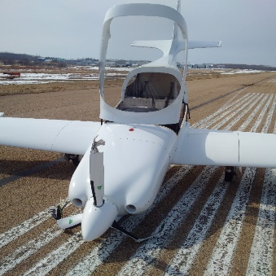
The engine was at lower power and combined with a wood/composite MT propeller, the engine incurred no damage. The engine was inspected per the Lycoming propeller strike directives, a new propellor was installed and the other damage was repaired, and the aircraft returned to service in 2020 following the installation of a new instrument panel.

Price: $120,000 USD

