

***Gabriel Enterprises***

**Hydraulic Pump Controller**

***14 Volt Only***

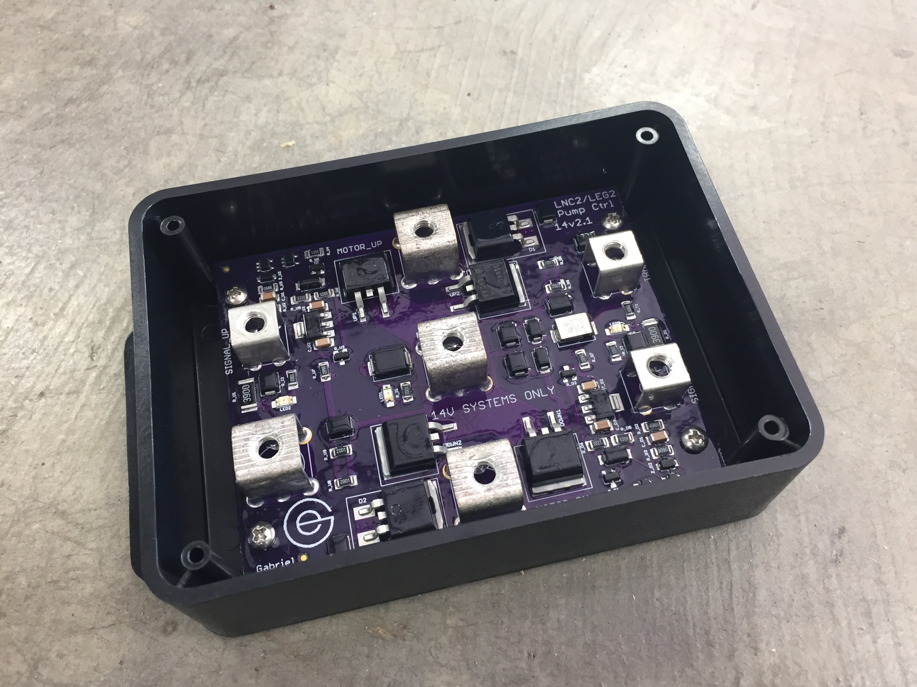

Item # 10

Retail value $295

**2022 LOBO/Lancair landing Auction Item!**