

**4-Day Stay at the World Famous Spruce Creek Fly-In Community (7FL6) in Port Orange Florida.**

***Modest 3-Bedroom, 2 bath home. Runway view from the Lanai***

**Hangar, 6 seat golf cart & SUV available on site. Runway 3800’ x 175’**

Most dates available for 2022/2023 (3/23 to 4/2 currently booked)

For more info/pictures Contact Beth or Tom Sullivan 906-282-4375 / 906-458-6989

** Reservation Requests are based on Availability at time of booking

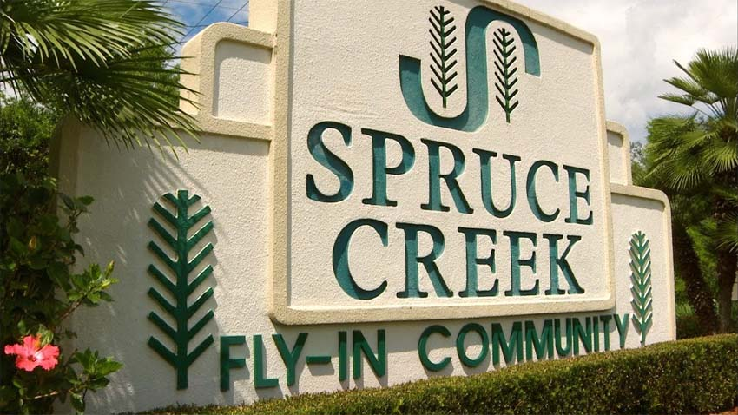

Item # 25

Retail value $2500

**2022 LOBO/Lancair landing Auction Item!**