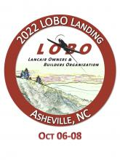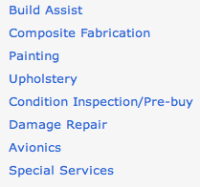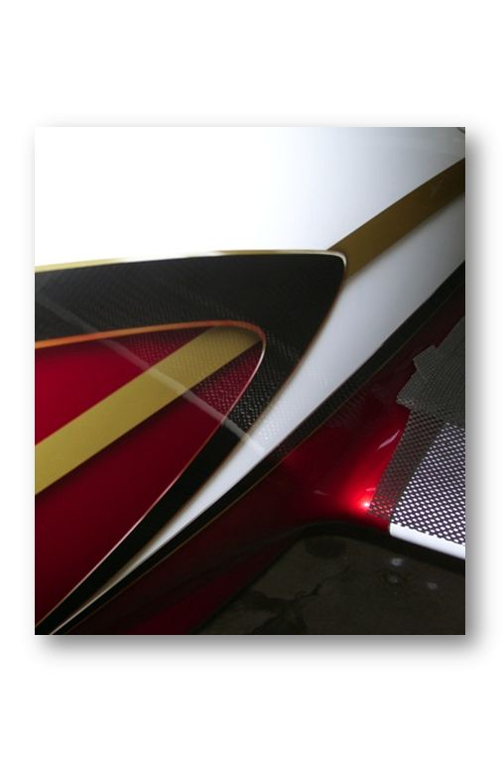

50% off on up to $2000 in services. Cash value $1000

Retail value $1000

“The oldest continuously operating Lancair shop in the business” Airframes Inc., aka **Brad Simmons** has made a name for itself for excellent workmanship and depth of Lancair knowledge.

You can use your certificate for a variety of services listed to the right.

Let the experts at Airframes Inc. show you how paint design and color choices can make the difference between a nice aircraft and truly memorable one.

Item #4

**2022 LOBO/Lancair landing Auction Item!**