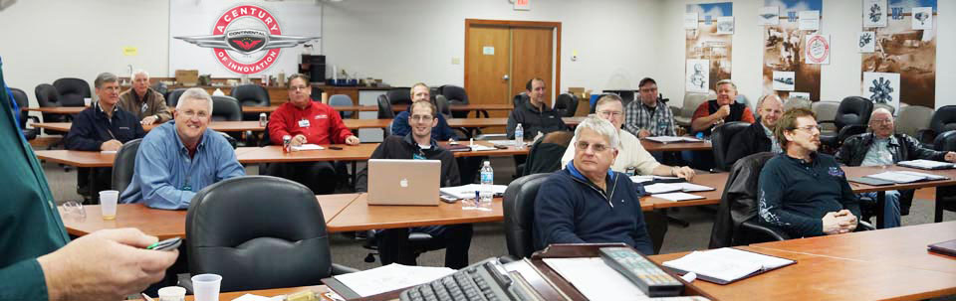 

Item # 8

Held at Continental's facility in Mobile, AL. This 4 day Level 1 Technician Factory Training Course does not include travel, meals or lodging.

***The course must be redeemed by the end of 2023***

**Certificate for 4 day course**

**Aviation Technician Factory Training Course**

Retail value $1000

**2022 LOBO/Lancair landing Auction Item!**