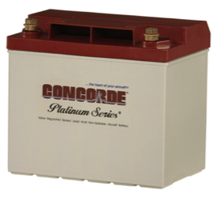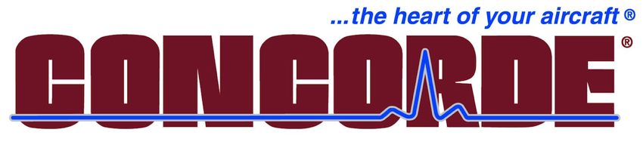 

**Certificate for one Concorde Battery**

For Lancair application of your choice.

RG-24-10

RG-24-16

Concorde batteries are in use by military forces worldwide. Their valve-regulated aircraft battery is no maintenance, non-spillable and highly reliable, offering better vibration/shock resistance and cold perfor-mance than flooded lead-acid batteries. Flying in legendary aircraft like the Learjet, Citation and Stealth Figher, you can be sure a Concorde battery will provide years of trouble-free service in your Lancair.

Item #7

Retail value $780

**2022 LOBO/Lancair landing Auction Item!**