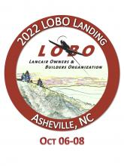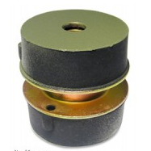

Retail value up to $1900

LORD mounts from LORD Corporation set the standard for elastomeric engine mounts more than 50 years ago. In fact, they defined it.

Today, genuine LORD mounts continue to prove themselves at all levels of general aviation. That's why most major OEMs spec LORD mounts from LORD Corporation. And, why an overwhelming majority of service shops use only original LORD mounts.

Certificate for your choice of a set of mounts for any Lancair piston aircraft.

Item #20

**2022 LOBO/Lancair landing Auction Item!**