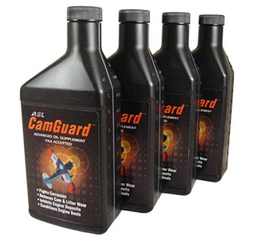 

CamGuard 4-pack

ASL says CamGuard addresses unique problems related to corrosion, wear, deposits and seal degradation in piston engines, and that it improves the performance of with all aviation oils including mineral based, and semi-synthetic types. Its corrosion control properties make it particularly beneficial for infrequently used engines.

Item #6

Retail value $120

**2022 LOBO/Lancair landing Auction Item!**